**IVIETTECH CENTER**



**Project overview:**

**WEBSITE APARTMENT BOOKING**

**MY NAME**:

LE THANH TAN

**INTRUCTOR:**

LE BA THANH TUAN

*Đà nẵng, 29/10/2020*

**PROJECT OVERVIEW**

|  |  |
| --- | --- |
| **Name of project** | WEBSITE APARTMENT BOOKING |
| **Start day – End day** | 1/-10/2019  31/10/2019 |
| **Center** | Iviettech center |
| **Intructor** | Le Ba Thanh Tuan |
| **Member** | Le Thanh Tan |

**PART I:HEADING**

Nowadays, the application of information technology and computerization is considered as one of the decisive factors in the operations of companies, the organizations it plays a very important role can take. powerful breakout

Along with the continuous development of computer technology and electronic networks, the company Information technology is also conquered by high-level technologies Peak after peak. The internet is one of the products there is has great value and is increasingly becoming an indispensable tool, a foundation for global information transmission and exchange.  
Now everything related to the information becomes easy for the user: it only takes a computer connected to the internet and a tracing data stream almost Immediately… the whole world of your concern will appear, with complete information news, images and sometimes even sounds if you need it ...

By internet, we have done many jobs at a faster speed and The cost is much lower than the traditional way. This is what motivates the birth and development of e-commerce and e-government around the world gender, significantly changing the cultural face, improving the quality of human life.

In production and business activities, now e-commerce has confirmed is the role of promoting and promoting the development of the business. For one stop goods or shop the promotion and introduction to customers of new products Responding to the needs of customers will be necessary. So how must promote it Build a Website for your store to promote all products its sale.

**2. PURPOSE AND MEANING OF THEME**

**2.1. The purpose of the topic**

- Website Apartment booking

- Research on Wesbsite development technologies

- Provide customers with accurate information about rooms with the way of booking over the internet.

**2.2. The meaning of the topic**

- Meeting the growing needs of the society for renting and buying, building an effective working environment.

- Promoting online booking development.

- Shorten the gap between buyers and sellers, create an online website that can quickly provide information as well as exchange and purchase mobile phones over the network.

- Room management is easy.

***2.2.1. In terms of topic theory***

The entire program and explanation of the topic will become a research document, a quick reference, easy to understand, practical for users, who love Web and application technology, especially in the field of construction. Web management in React environment

***2.2.2. In terms of the practicality of the topic***

Contribute to the optimization of the management process of Trading Co., Ltd., eliminating the costs of advertising, etc., thereby increasing efficiency

**3. RESEARCH SUBJECTS**

- Customers, suppliers, business partners

- Company management documents

**4. RESEARCH SCOPE**

- Time: 1 month

- About content:

+ Room rental partners

+ Learn more about Json-server

+ Learn more about HTML ,CSS ,JavaScript, và framework React JS

**5. RESEARCH METHODS**

- Find out relevant documents (Framwork React, booking process, ... ..)

- Analysis and selection of solutions

- Synthesize materials related to software development and construction

- Comments from experts

**6. OBJECTS OF USE**

- There are 2 basic user objects that are users and administrators:

- User*:* Through the Website, customers can view information, choose their favorite rooms anywhere, even in their office..

-Adm*ịn*: Admin has full rights to use and update products, invoices, manage customers, ensure the safety of the Website.

**PART II : LIST OF THEMES**

# CONCEIVE

# 1.1. Build personal ideas

# 1.1.1. Member

* Full name: Lê Thanh Tân
* Specialty: Software engineering

Idea name: Website Apartment booking

October 1, 2020

**Describe the product idea**

* Today, many Web sites have been born and almost completed, but in recent surveys, most of the current Webside have many shortcomings that need to be fixed such as: Lack of security, many websites still have. advertising, designing an unattractive interface .... Since then we need to build a more complete web such as a more eye-catching interface, ads are arranged reasonably, and information is clearly shown. clear, has higher security.
* language for software implementation:
* HTML
* CSS
* React JS
* Json server
* Evaluate the student's knowledge base
* System design analysis: Learned
* Object oriented design analysis: Learned

1. Programming languages ​​(HTML, CSS, React JS): Learned
2. Evaluate the product's ability to develop

|  |  |  |  |  |  |
| --- | --- | --- | --- | --- | --- |
| Estimate how many people will benefit from your product | | | 1500 | | |
| Estimate the number of people who will spend money on your reservation | | | 300 | | |
| List the types of audiences that will benefit from your product idea (at least 1, at most 5) | | | Customers, partners, suppliers ... | | |
|  | medium | Rather | | High | Very high | |
| Evaluate how likely investors will spend money on your product ideas |  |  | | X |  | |
| Estimate how many years your product will be stay on the market until it is replaced | 2 year | | | | | |
|  | medium | Rather | | High | Very high | |
| Estimate how difficult it is to successfully develop your product |  | X | |  |  | |

|  |  |
| --- | --- |
| Estimate the amount of time it takes to develop your product | 4 month |

**Phần III: DESIGN**

**2.1. Current status survey**

Building a room rental website has the following basic components:

* The homepage of the website makes it possible for everyone to see rooms where users can view rooms and make reservations
* A login and registration screen where users can create and access the system
* Admin home page includes information system to manage reservations, posts, accounts, terms, feedback from customers
* The user's home page includes all room listings and reservations, searches
* The homepage of the system is used to post pictures of product, price information and room names, feedback from users

**2.2. Functional analysis of the system**

1. Input output information of the system
2. Input information:

* Room information
* Feedback

Agents of the system:

* Admin
* Customer

## DESIGN PROTOTYPE

### 3.3.1. General interface diagram

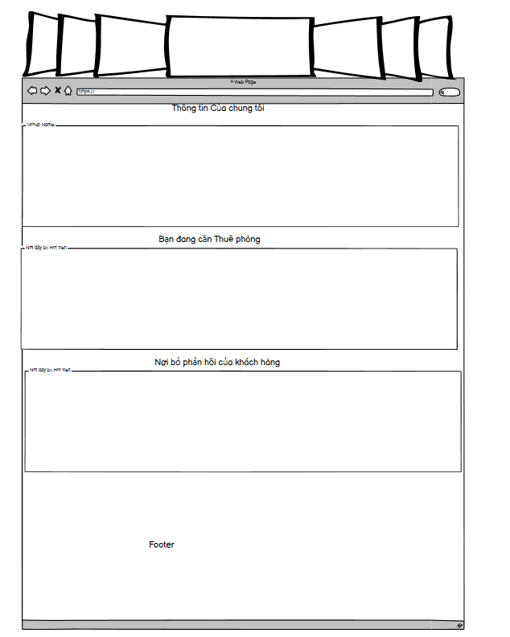

*Hình 5.0 Home page interface*

|  |  |  |  |
| --- | --- | --- | --- |
| Display | Home page | | |
| Describe | Display information interface about the home page | | |
| Show counter | Click on the table to select the room view | | |
| Content displayed | | | |
| Item | Type | Data | Describe |
| Trang Chủ | Button |  | Click Home |
| Thuê phòng trọ | Button |  | Click to see the room |
| Chủ nhà | Button |  | Click to view the host's blog |
| Đăng Nhập | Button |  | Click login |

### 3.3.2. Sơ đồ giao diện Trang thuê phòng trọ

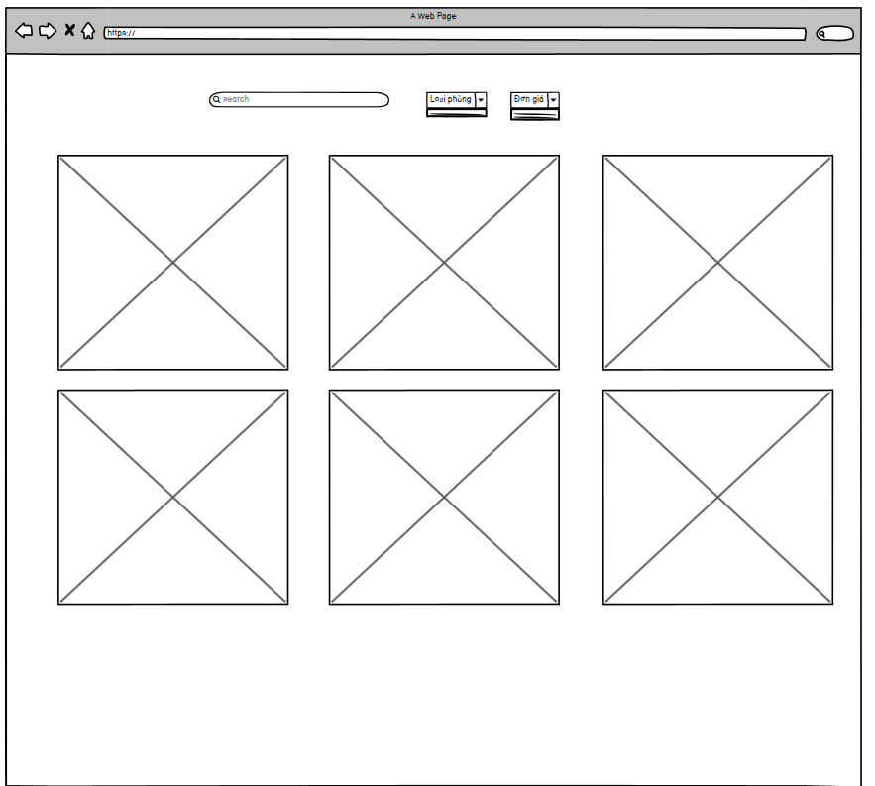

*Hình 5.1 Layout of the room rental page*

|  |  |  |  |
| --- | --- | --- | --- |
| Display | Thông tin trang thuê phòng trọ | | |
| Describe | Hiển thị giao diện thông tin về danh sách thuê phòng | | |
| Show counter | Click vào bàn chọn phòng và xem phòng | | |
| Content displayed | | | |
| Item | Type | Data | Describe |
| Trang Chủ | Button |  | Click Home |
| Thuê phòng trọ | Button |  | Click to see the room |
| Chủ nhà | Button |  | Click to view the host's blog |
| Đăng Nhập | Button |  | Click login |
| Search | Input |  | Click to search |
| Images | Images |  | Click image |
| Chi tiết | Button |  | Click to view room |

### 3.3.3. *Layout of the Room Details page*

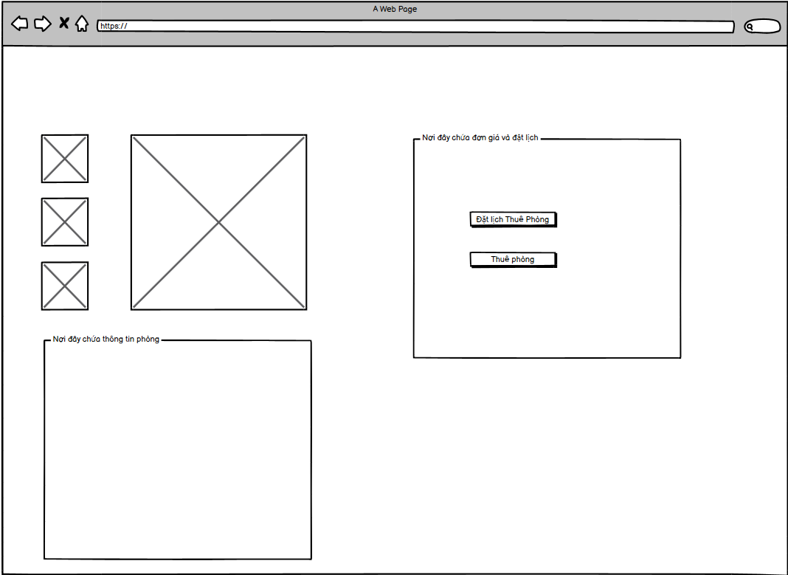

*Hình 5.2 Layout of the Room Details page*

|  |  |  |  |
| --- | --- | --- | --- |
| Display | Information Room details | | |
| Describe | Show interface information about the rooms | | |
| Show counter | Click to see the details of the room | | |
| Content displayed | | | |
| Item | Type | Data | Describe |
| Trang Chủ | Button |  | Click Home |
| Thuê phòng trọ | Button |  | Click to see the room |
| Chủ nhà | Button |  | Click to view the host's blog |
| Đăng Nhập | Button |  | Click login |
| Images | Images |  | Click image |
| Đặt lịch thuê phòng | Button |  | Click to book a room rental |
| Thuê phòng | Button |  | Click to choose to rent a room |

### 3.3.4. *Layout of the Room Details page*

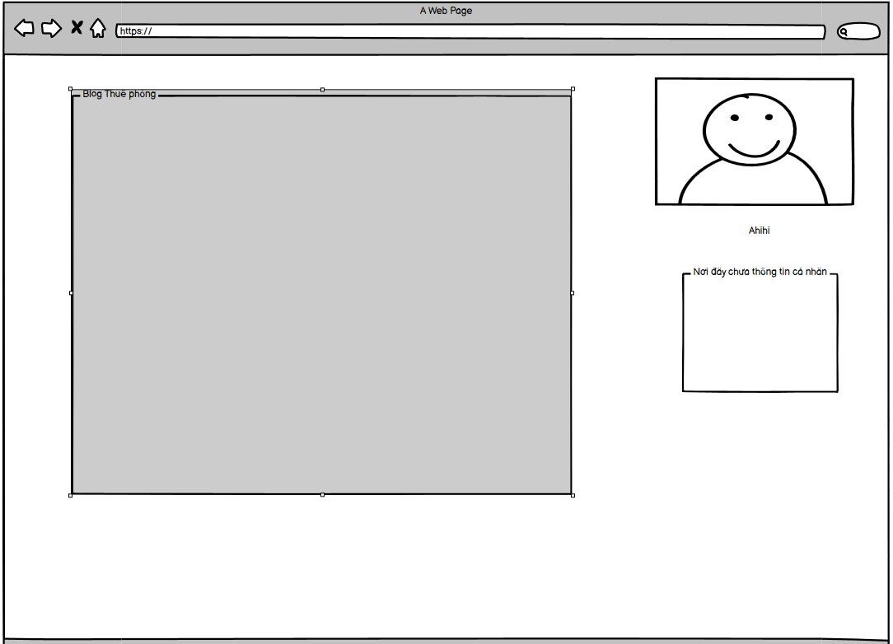

*Hình 5.4 Home page interface*

|  |  |  |  |
| --- | --- | --- | --- |
| Display | Information of owner and blog | | |
| Describe | Displays the information interface of the host and the blog | | |
| Show counter | Click to view the host's blog | | |
| Content displayed | | | |
| Item | Type | Data | Describe |
| Trang Chủ | Button |  | Click Home |
| Thuê phòng trọ | Button |  | Click to see the room |
| Chủ nhà | Button |  | Click to view the host's blog |
| Đăng Nhập | Button |  | Click login |
| Images | Images |  | Click image |
| Personal information | Div |  | Information of the owner |

### 3.3.5. Login Page interface

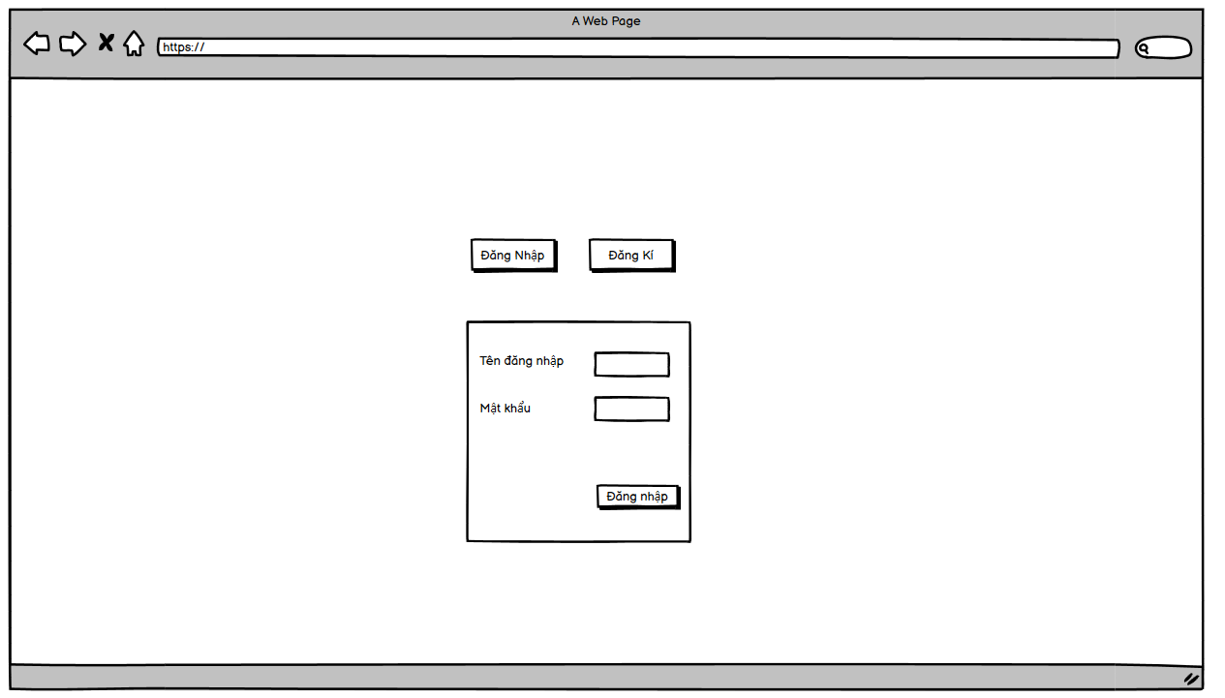

*Hình 5.5 Login Page interface*

|  |  |  |  |
| --- | --- | --- | --- |
| Display | Login information | | |
| Describe | Displays the Web site login functions | | |
| Show counter | Click to login to the Website | | |
| Content displayed | | | |
| Item | Type | Data | Describe |
| Tên tài khoản | Textbox |  | User login account |
| Mật khẩu | Textbox |  | Login password of your account |
| Đăng nhập | Button |  | Click when you enter all the information |

### 3.3.6. Registration page interface

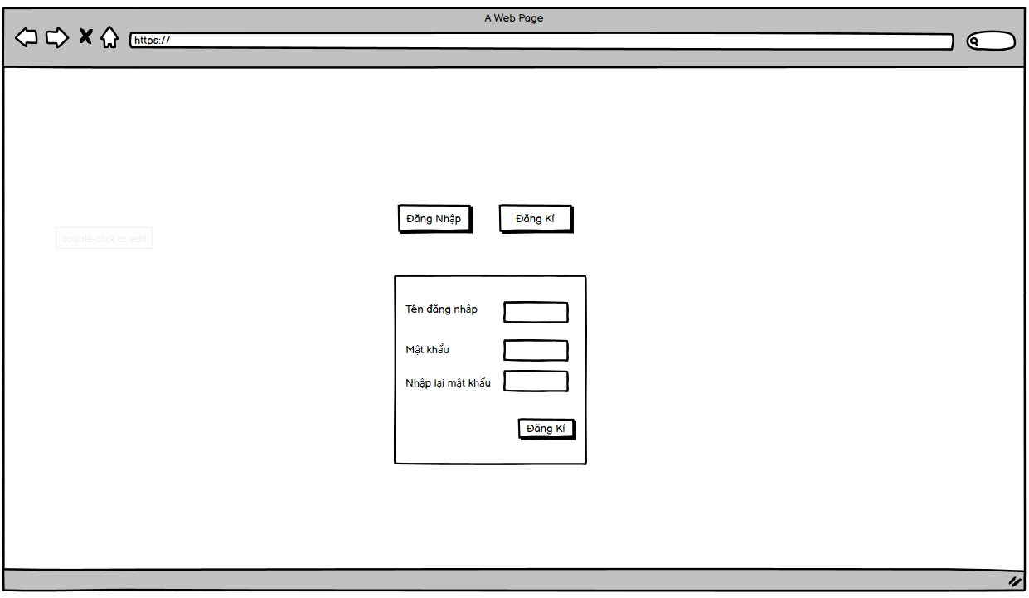

*Hình 5.6 Registration page interface*

|  |  |  |  |
| --- | --- | --- | --- |
| Display | Registration Information | | |
| Describe | Displays the Register functions of the Web site | | |
| Show counter | Click to Register of the Website | | |
| Content displayed | | | |
| Item | Type | Data | Describe |
| Tên Đăng Nhập | Textbox |  | User's registered account |
| Mật khẩu | Textbox |  | Login password of your account |
| Họ và tên | Textbox |  | Client's first and last name |
| Số điện thoại | Textbox |  | Customer's phone number |
| Địa Chỉ | Textbox |  | Client's address |
| Đăng nhập | Button |  | Click when you have registered full information |

# PART IV

# OPERATION

## 4.1 SYSTEM DEPLOYMENT

4.1.1. Home interface

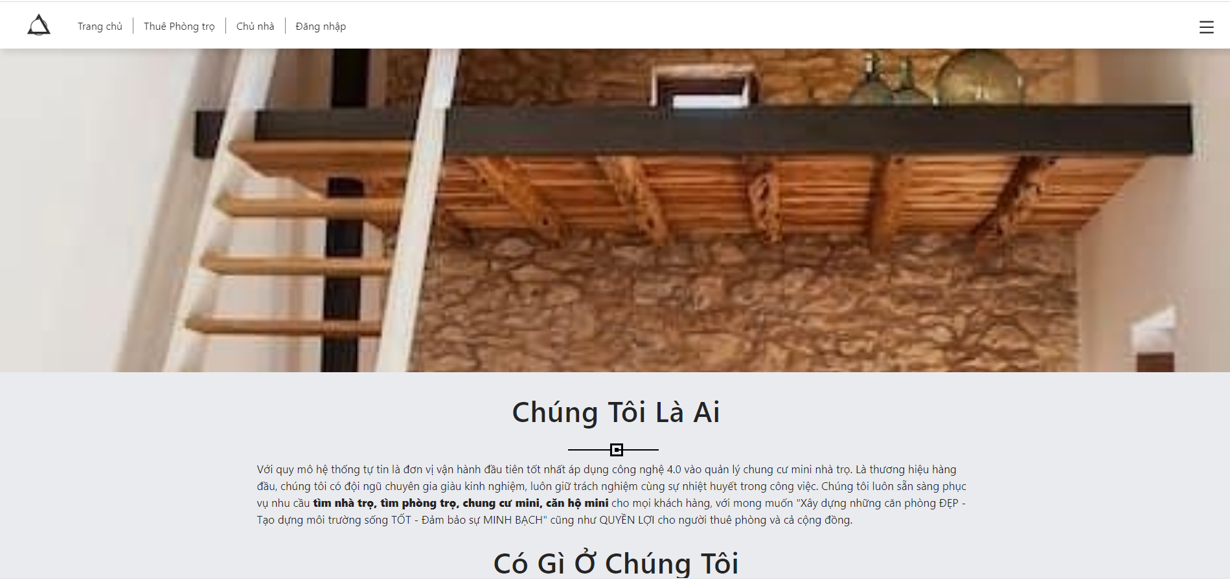

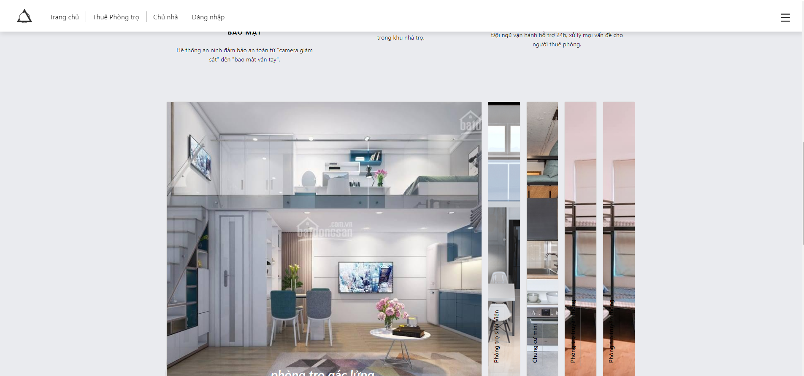

*Hình 4.1 Giao diện trang chủ*

The homepage "http: // localhost: 3000 /": is the main page, containing all the items to choose from. From the home page, customers can find all necessary information:

- Information about all kinds of products with close, friendly and easy-to-use interface ... from which customers can book their favorite rooms, suitable for their budget ...

- Good articles about rooms selected by system administrators ...

4.1.2. Layout of Accommodation list

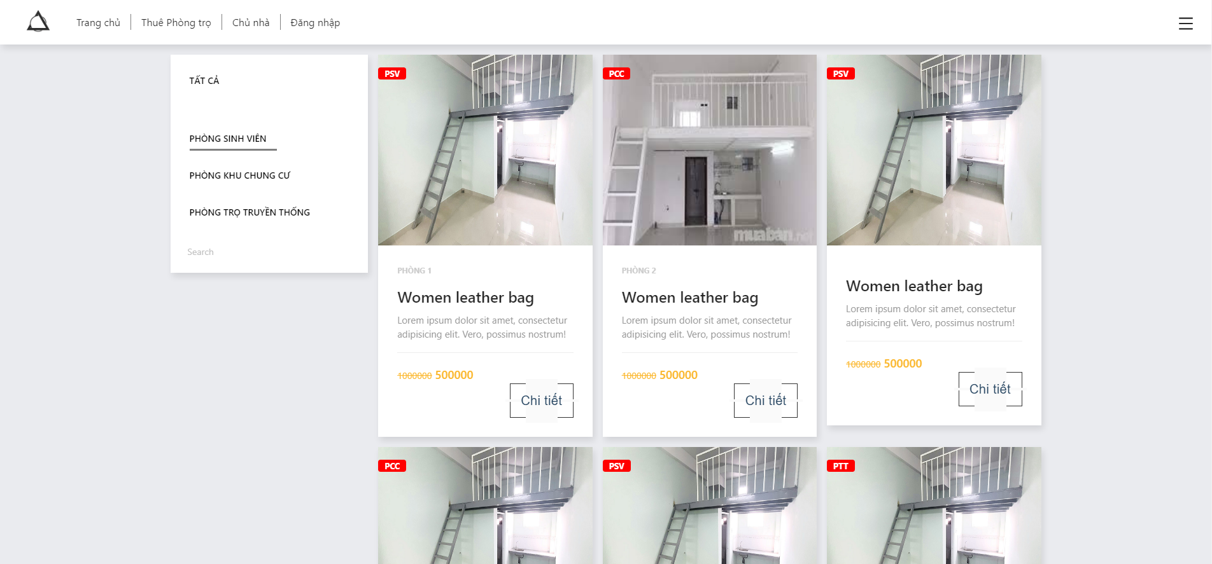

*Hình 4.2 Layout of Accommodation list*

The page "http: // localhost: 3000 / apartments" is a page that displays detailed information about the product: price, ... to help customers have an overview of the room. As the basis for customers to have a decision to rent a room

4.1.3. Layout room details page

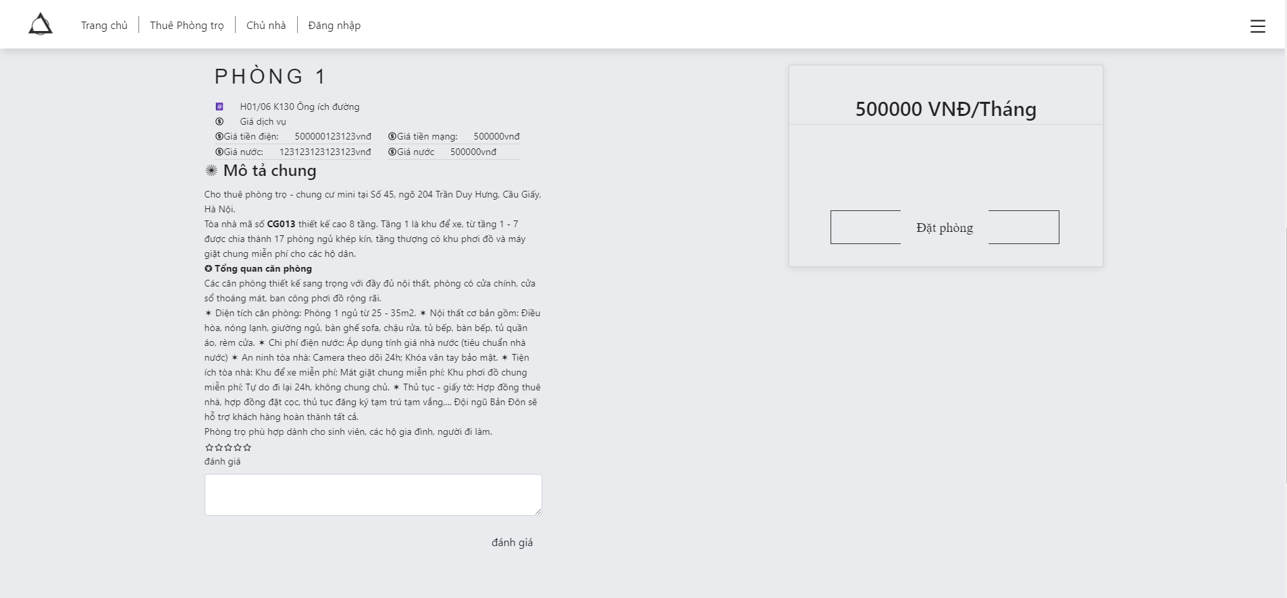

*Hình 4.3 Layout room details page*

The page "http: // localhost: 3000 / apartment / 1" is the page that displays room details, ... to help customers have an overview of each room.

4.1.4. Home page interface

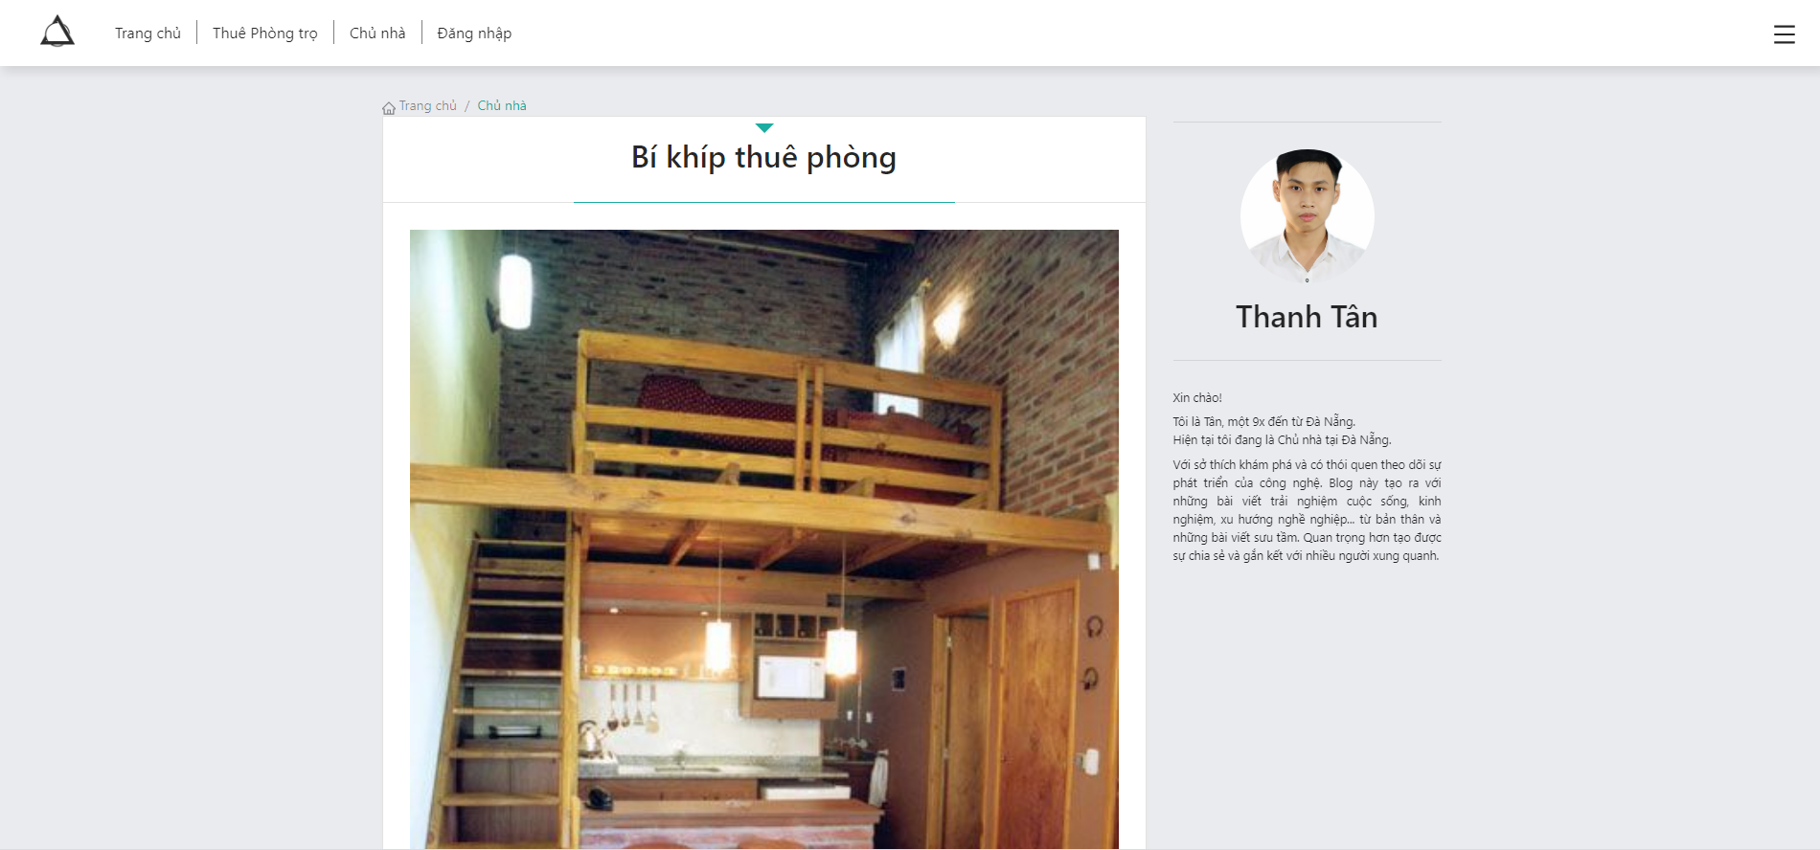

*Hình 4.4 Home page interface*

The page "http: // localhost: 3000 / host" is the page that displays the host information, ... to help customers have an overview of the host.

4.1.5. Login page interface

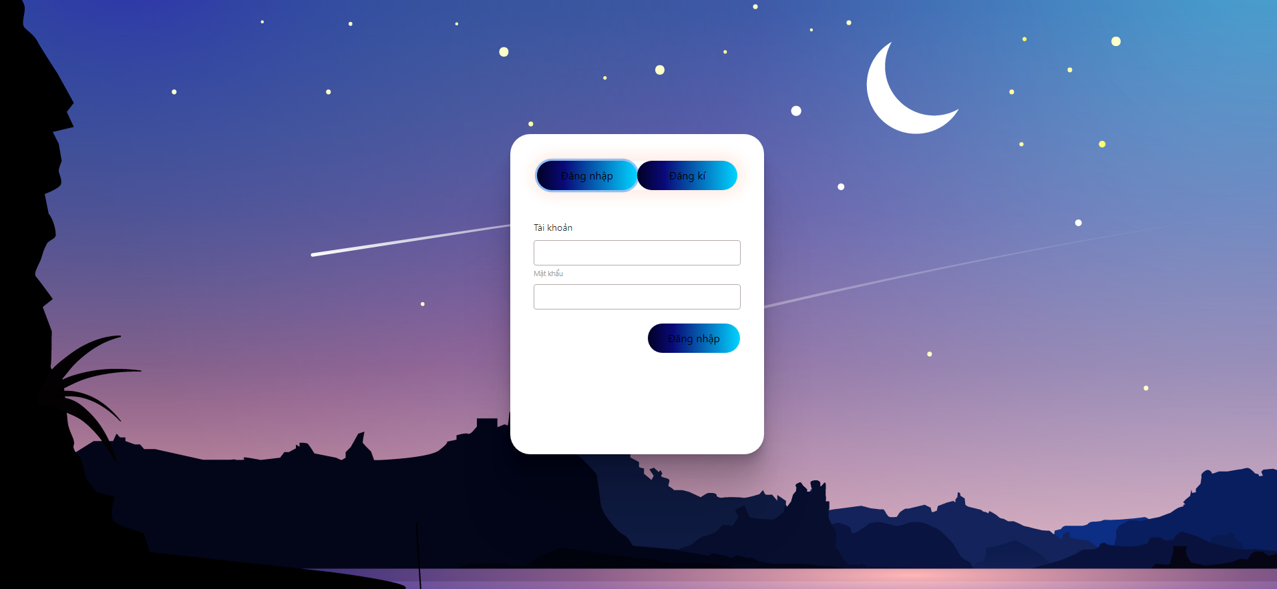

*Hình 3.5 Login page interface*

The page "http: // localhost: 3000 / login" is the page where the customer will enter his User and Pass to log into the website, if there is no account, click on the Register button to create a new account.

4.1.6. Registration page interface

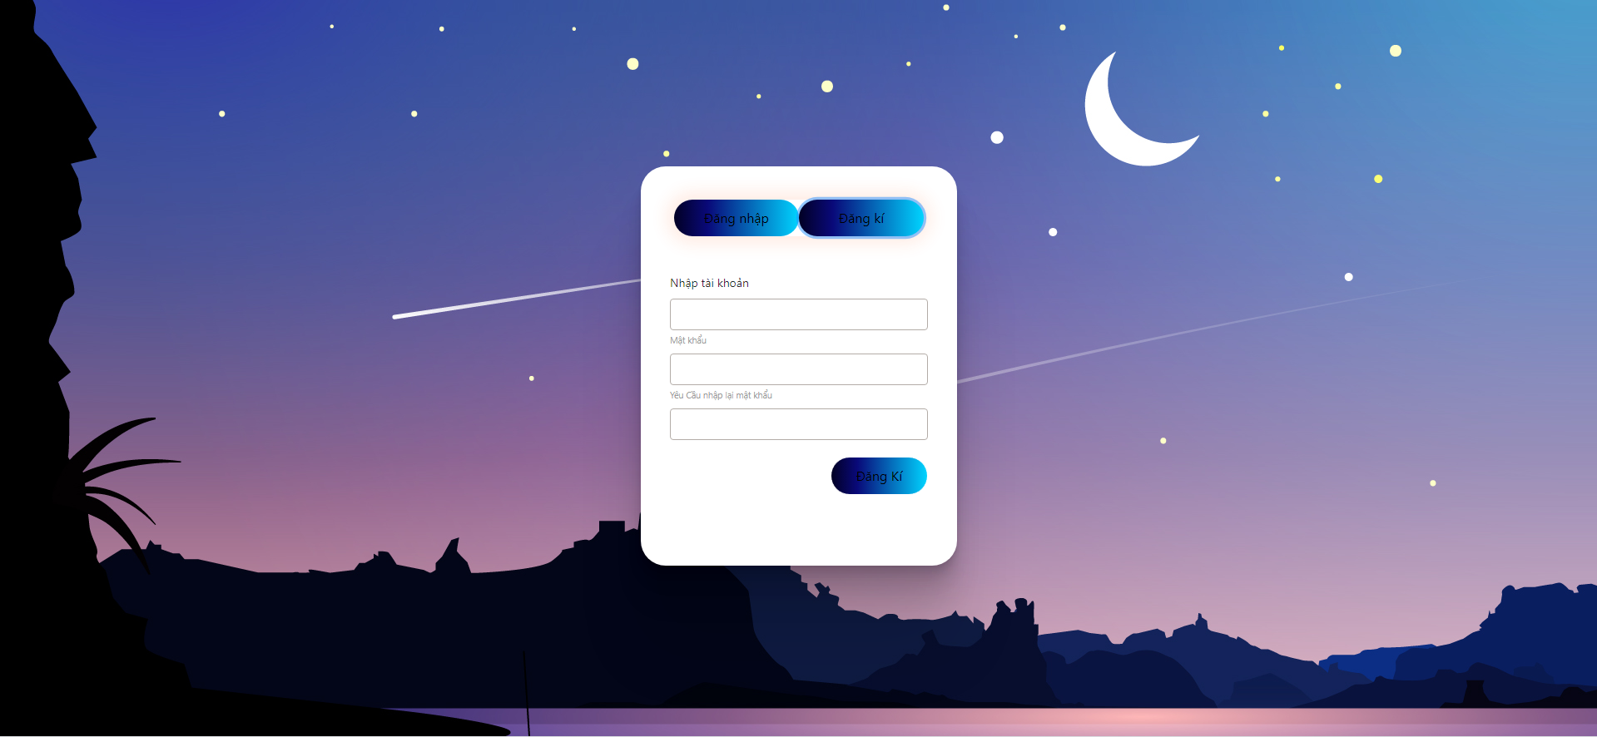

*Hình 3.7 Registration page interface*

Page "http: // localhost: 3000 / login" Here, customers will fill in personal information and register for themselves an account, to be used to make purchases at the website.